Class Assignment 7

JQuery and JQqeryUI

Create a HTML page with an accordion into the page.

The first item of the accordion will contain a tab with 3 items.

The first item of the tab will contain a button “Click Me”

When you click on the button it will show a dialog with “OK” and “Cancel” button.

When you click on the “OK” button it will pop up another modal with “cancel button”.

**Use JQuery Framework and JQuery UI to solve the problem.**

**Step by step browse:**

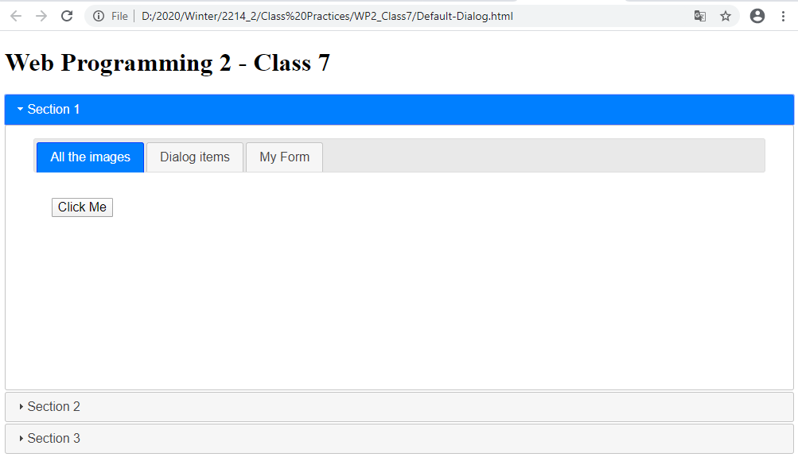

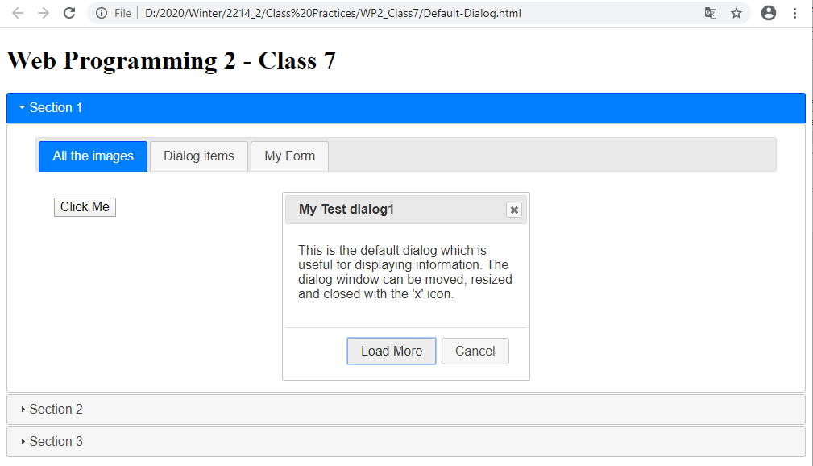

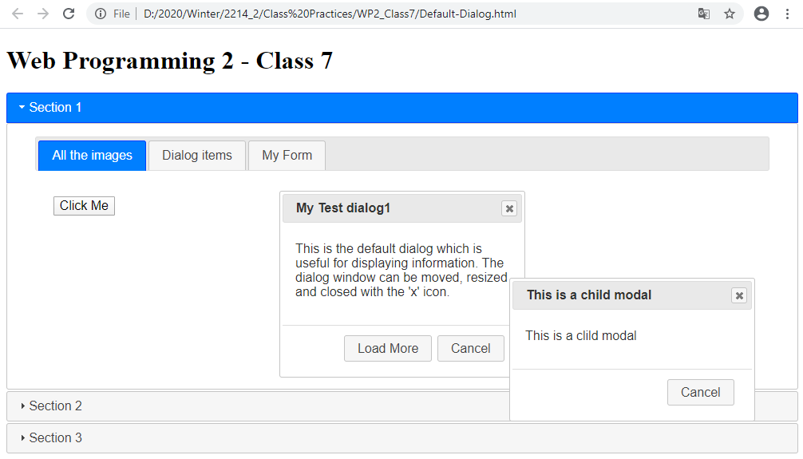

**How to submit:**

Compress the folder.

Take Screen Shots of your HTML, CSS, and JavaScript codes attach those to this file.

Upload the compressed folder and word document in moodle.

**Answer here:**

